Final Project

*Done by*

*Devasmit Dutta*

**Ans 1: -**

For plate-1,

* d_max = 8.52e-4 m (Kirchhoff element)
* d_max = 8.54e-4 m (R-M element with [2,1] integration)
* d_max = 7.47e-4 m (R-M element with [2,2] integration)
* d_max = 8.52e-4 m (Exact solution for Kirchhoff element)
* d_max = 8.54e-4 m (Exact solution for Mindlin element)

**Ans 2: -**

For plate-2,

* d_max = 2.4e-6 m (Kirchhoff element)
* d_max = 3.63e-6 m (R-M element with [2,1] integration)
* d_max = 3.63e-6 m (R-M element with [2,2] integration)
* d_max = 1.7e-6 m (Exact solution for Kirchhoff element)
* d_max = 2.26e-6 m (Exact solution for Mindlin element)

**Ans 3**: -

Kirchhoff plate element is fundamentally based on the Kirchhoff’s plate theory where the shear deformation is forced to be zero. In this consideration, we need to enforce a requirement that the rotation quantities, dw/dx and dw/dy must be continuous across the element boundaries. At each node, we define three degrees of freedom, {w, dw/dx, dw/dy}. Depending on this convention, we consider a 12-term polynomial that must be selected for the interpolation of the displacement w within the element. As the displacement is a cubic function of (x, y), hence it is conforming, however the normal slope is not conforming, along the element boundaries. Kirchhoff plate elements are hence considered non-conforming and complete type of elements.

Then based on this, we need to populate the C matrix by evaluating the polynomial terms at each node. Finally, we need to obtain the B matrix, which is the 2nd order derivative of the P_bar terms, respectively.

Once, we have got the B matrix, then we can obtain the K matrix, by doing the symbolic integration of B’*D*D matrix.

However, for Mindlin plate elements, we need to consider the shear deformation part, and hence three independent degrees of freedom, {w, theta_x, theta_y} respectively, where theta_x is not equal to dw/dx and theta_y is not equal to dw/dy. Hence, in this type of element, only the deflection and normal rotations need to be continuous between not their derivatives. Hence, Mindlin plate elements are considered to be conforming and complete type of elements. A similar approach is followed here to calculate the stiffness matrix, however, here we need to add the stiffness matrix contribution for both K_b (bending part) and K_s (shear part). Also, we need to follow the Gauss quadrature rule to evaluate the integral of B’*D*B part for both bending part and shear part numerically, by multiplying the function values with their corresponding weights. So, therefore, Mindlin plate elements are found to useful for thicker plates with a/h ratio < 20, however, Kirchhoff plate elements are found to useful for thinner plates with a/h ratio > 20. Depending on the type of scenarios considered, generally, in theory, Mindlin plate elements and Kirchhoff plate elements should converge to the same final deformation value, however, in practical, due to shear locking phenomena, there is still a gap in these two values, and hence, if Mindlin plate theory is required to be used for thinner plate elements a reduced order integration is suggested to be performed.

Let us address the issues mentioned in the question from our study of the two types of elements with different geometric, support and load configurations.

For plate 1, we have our a/h ratio =40 which is > 20, hence this is a thin-plate. On the other hand, for plate 2, we have a/h ratio = 4 which is < 20, this is a thick plate. Let’s see the convergence graphs for the two plates, for mesh sensitivity analysis for mesh-size discretization as [2,2], [4,4], [8,8], [16,16], [20,20], [40,40] respectively:

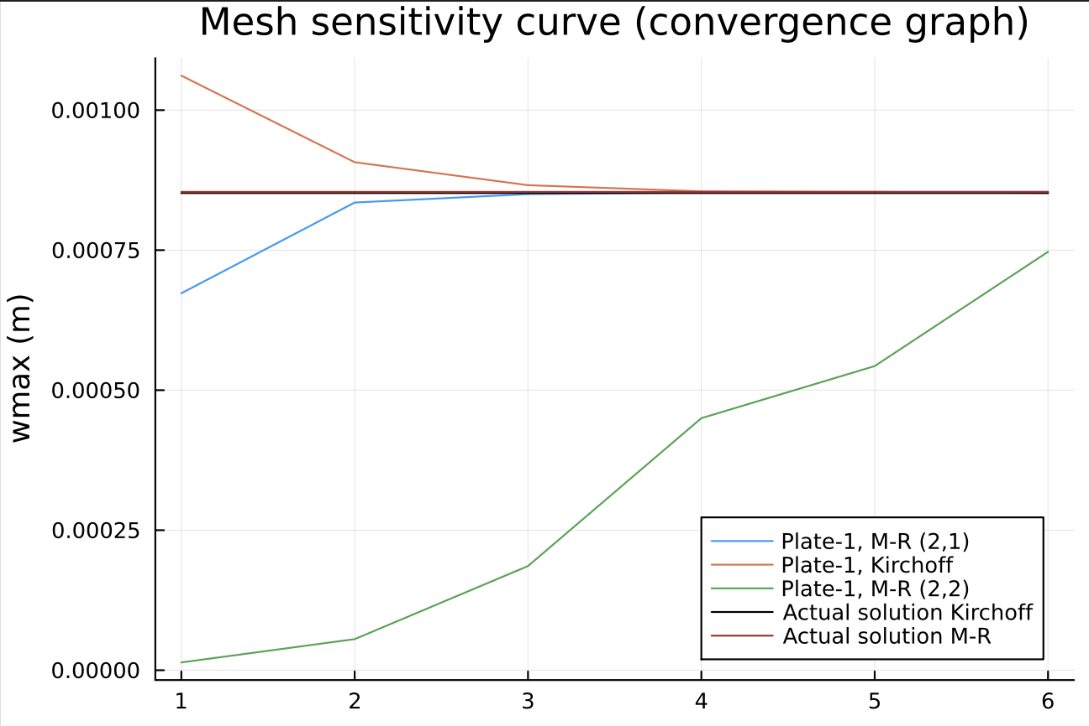

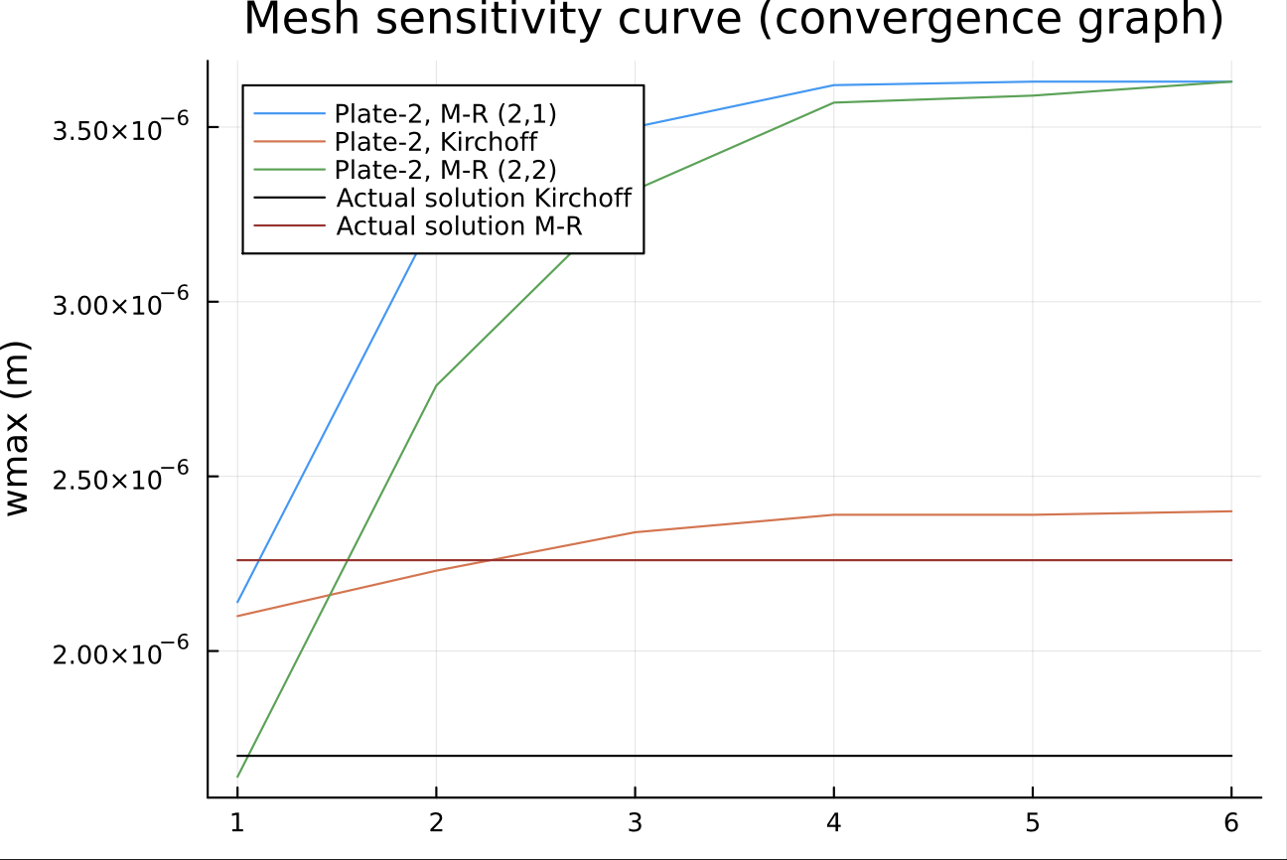

As we can see as the mesh size is reduced then the FEM solution converges to the actual analytical solution for plate-1, for both Kirchhoff and Mindlin plate elements. However, for plate-2, Kirchhoff plate element and Mindlin plate element, it does not converge.

Let’s take a look into the constant resp, that is d_max/(qo*a^4/D), for the plate-1. As plate-1 is a thin-plate, hence this plot will help us to analyze shear-locking phenomenon.

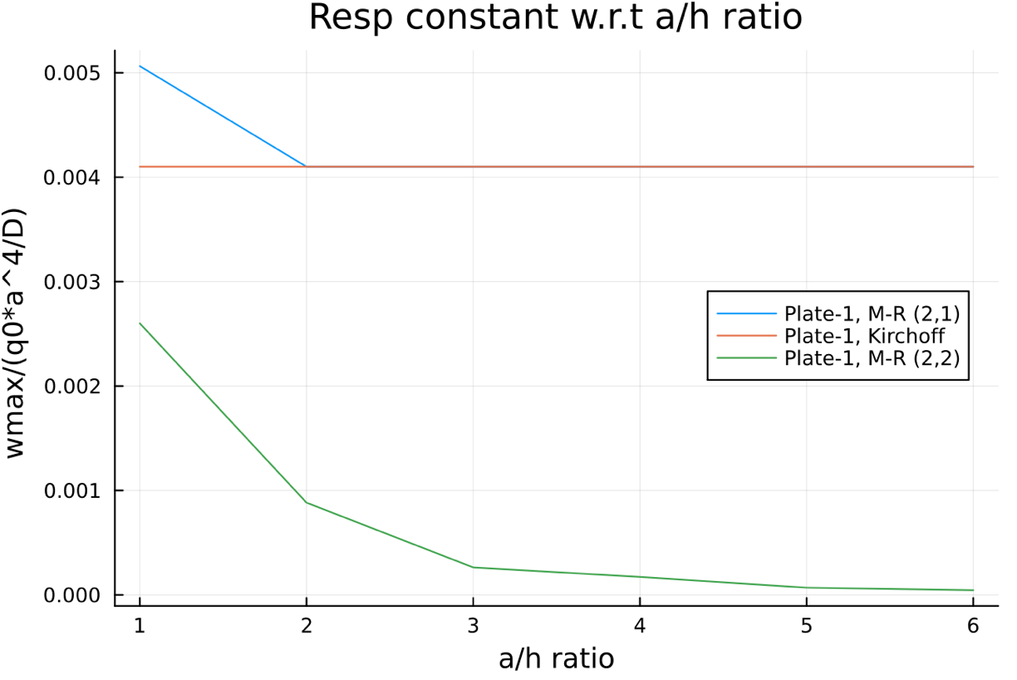

We can clearly understand from this plot that in order to mitigate shear-locking phenomenon in the Mindlin plate elements, we need to follow the reduced order integration. This is because for [2,1] integration we don’t get a fake shear strain because of the reduced order integration for the shear part. However, for [2,2] integration we are not able to prevent the fake shear strain from coming because of the complete integration of the shear contribution part in the stiffness matrix. Also, we see Kirchhoff plate elements does not suffer from shear-locking phenomenon and converge pretty quickly.